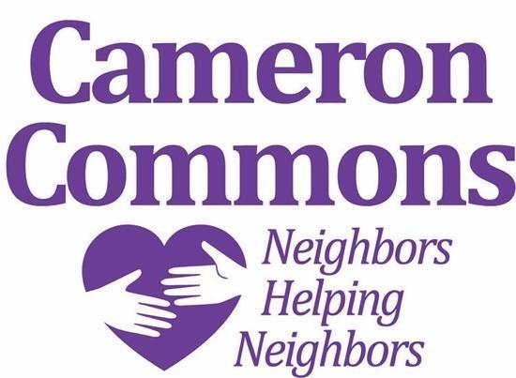**Cameron Commons**

**Accomplishments 2020**

**Social Committee**

▪ Pub Night and Lunch Bunch were held until mid March when face-to-face activities had to be cancelled due to the COVID virus.

▪ The two women’s groups, the Juliets and Marty’s Mixed Nuts, met in person until April when meetings continued to be held twice monthly through Zoom.

▪ Since all in-person social activities were cancelled, two Zoom art activities were offered in December, led by local artist Kyle Highsmith.

**Education Committee**

▪ Three forums were held at the YMCA:

— Retirement Finance (36 in attendance)

— Protect Yourself from Cyber & Investment Fraud (24 in attendance)

— Brain Health (45 in attendance)

▪ One forum, Aging Decisions for Yourself or Loved Ones, had to be cancelled twice, once due to weather and once due to the pandemic.

▪ Two Zoom tutorials were presented in April and May; 16 people attended each.

▪ Four forums are planned for 2021:

— Moving Your Financial World Online: How to Do It Safely

— Aging Decisions for Yourself or Loved Ones

— Shoulder, Hip, and Knee Health: Common Conditions, Treatments

— Strategies to Keep Your Joints Healthy, and the History of Oberlin Village.

**Communications Committee**

▪ A Cameron Commons logo was selected (above).

▪ The Cameron Commons trifold brochure was printed and distributed. Contact information included the two Google Voice phone numbers.

▪ A Cameron Commons newsletter was distributed via email in the fall.

▪ The Neighborly Services short-term assistance request form was designed and will be distributed in January.

**Neighborly Services Committee**

▪ The Cameron Commons brochure was completed with two Google Voice contact numbers.

▪ A new neighborly short-term assistance request form was completed.

▪ Approximately 30 people requested assistance. Nine persons received short term assistance in the home.

▪ Points of Contact will now be known as “ambassadors,” some of whom are also Checkers who check in with neighbors in emergency situations. The Checkers were contacted before Hurricane Isaias in August to encourage them to check on their neighbors.

. A zoom meeting for the ambassadors and checkers is being organized and planned for January.

▪ The NCSU social work student made several visits before the stay in place order was initiated and she completed an evaluation of the forums. A new social work student began her internship in the fall.

**Finances**

▪ The board e-filed its required 2019 IRS report.

▪ The board adopted a more specified budget process and format.

▪ Cameron Commons must send the IRS gift acknowledgments to donors as documentation for tax deductions.

▪ All contributions, including in kind, need to be documented.

▪ The first tax return was filed with the IRS.

▪ The annual Village to Village Networks dues were paid.

**Board Business**

▪ One new board member was elected, and a board member agreed to serve as the new treasurer.

▪ The bylaws were amended to change the office of President-Elect to Vice President, who would have the option of succeeding the President or not.

▪ One-on-one orientation of new board members was planned rather than a group meeting.

▪ A proposal for reorganization of CC’s Dropbox files was approved.

**Miscellaneous**

▪ An advisory committee was created, with members John Wall (chair, Joann Sumner, and Flora Lea (Flea) Louden.

▪ A committee was set up to promote connection with area retirement communities.

▪ Outreach to other villages in the city was initiated through a meeting in November, but it was later decided that it was too soon to try to incorporate additional areas of the city at this time.

▪ A contract was signed with Vitality Society, a Zoom platform for exercise and arts programming, for our members to receive a reduced rate of $19.99/month. Cameron Commons will receive a one-time bonus of $20 for every member who signs up and remains for two months.

▪ Seven members attended the Zoom National Village to Village Network conference in October.

▪ Two very successful food drives were held in April and November which raised money and large contributions of food for five organizations.

▪ There was an organized yard waste pick up from 52 homes after the city stopped this service.